Supply Chain Management (SCM) — NPTEL
Week 8 · Session 2: Facility Location Decision — Centre of Gravity Method
1. Recap — Previous Session
- Last session: Break-Even Analysis for facility selection — choosing best from existing options at a given volume
- This session: Facility Location Decision — finding the optimal coordinates for a brand new facility

★ Facility Selection = choose from given options. Facility Location = find where to build new.

2. Case Study — Cooking Range Manufacturer
Background
- Manufacturer of high-quality cooking ranges — currently has a single assembly factory near Mumbai
- This factory serves the entire Indian market alone
- Rapid demand growth observed → CEO decides to build a second factory
- Task for SC Manager: find the optimal location for this new factory

Network Structure
- Parts plants (supply sources) in: Chennai, Kolkata, Hyderabad — will supply the new factory
- New factory must serve: Delhi, Bangalore, Mumbai, Pune, Chennai — 5 markets

Role | Node | City | No. of Nodes
Supply Sources | S1, S2, S3 | Chennai, Kolkata, Hyderabad | 3
Markets | M1–M5 | Delhi, Bangalore, Mumbai, Pune, Chennai | 5
New Factory | (x, y) | Unknown — to be determined | 1

Given Data (Parameters)
- Coordinate locations (X, Y) of all supply sources and markets
- Demand at each market and supply quantity from each parts plant
- Shipping cost per unit per mile — for both supply side and market side

★ Goal: find optimal (X, Y) coordinates for the new factory that MINIMIZES total transportation cost.

3. Centre of Gravity Method — Concept
- Analytical approach based on coordinate locations of supply sources & markets
- Considers demand, supply quantities and distances between nodes
- Finds the location that minimizes total weighted transportation cost
- Output: (X, Y) coordinates of the new facility

Key Variables

Variable | Meaning
X, Y | Coordinates of the new facility (decision variables — unknown)
Xi, Yi | Coordinates of supply source / market node i
F | Shipping cost per unit per mile (between facility & supply/market)
D | Quantity to be shipped between facility & supply source / market
d | Distance between the new facility and a given node (calculated)

4. Key Formulas
Euclidean Distance Formula
- Used to calculate distance between the new facility (x, y) and any node (Xi, Yi)

d = √ [ (X – Xi)² + (Y – Yi)² ]

- Apply for each of the 3 supply sources and 5 markets → 8 distances in total

Total Transportation Cost Formula
- Cost = sum of (shipping cost × quantity × distance) over ALL nodes

Total Cost = Σ ( F × D × d ) [over all supply + market nodes]

- In Excel: use SUMPRODUCT(F_range, D_range, d_range) function
- Initially X = Y = 0 → cost will be very high and non-optimal

5. Solving in Excel — Step-by-Step

1 | Data Entry  Enter unit shipping cost (F), quantity (D), and coordinates (X, Y) for all supply sources and markets in Excel
2 | Define Decision Variables  Create two cells for X and Y (new factory coordinates) — initialize both to 0
3 | Distance Calculation  Use Euclidean distance formula: d = √[(X–Xi)² + (Y–Yi)²] for every supply source and market node
4 | Total Transportation Cost  Use SUMPRODUCT function: Total Cost = Σ (F × D × d) across all nodes (supply + market)
5 | Optimize using Solver  Data tab → Solver. Set objective = minimize Total Cost cell. Changing variables = X, Y cells. Method = GRG Nonlinear. Run → get optimal (X, Y)

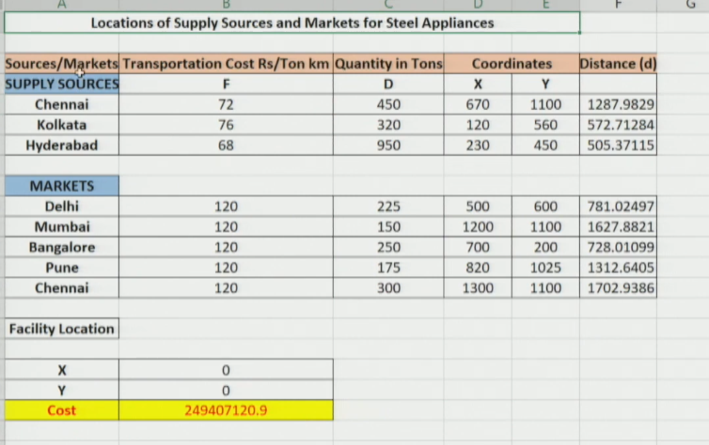

6. Excel Solver — Settings Detail
- Open Solver: Data tab → Solver
- Set Objective: Select the Total Cost cell → set to Minimize
- Changing Variable Cells: Select X and Y cells (decision variables)
- Solving Method: Use GRG Nonlinear — because the cost function is non-linear (distance formula has a square root)
- Click Solve → solution converges → keep solver solution
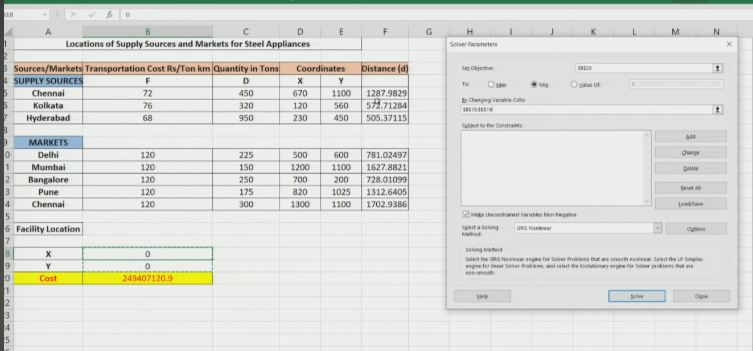
★ GRG Nonlinear is used because the Euclidean distance formula makes the cost function non-linear.

7. Result & Decision
- After optimization: X ≈ 500, Y ≈ 600 (initially 0, 0)
- These coordinates correspond to approximately Delhi
- Decision: locate the new factory near Delhi → minimizes total transportation cost

What if the Optimal Location is Not Feasible?
- Real-world constraints may prevent building exactly at (500, 600)
- Land unavailability, regulations, lack of infrastructure, etc.
- Solution: explore nearby areas close to the optimal coordinates
- Check logistics infrastructure, labour availability, regulations in those nearby zones
- Choose the nearest feasible location that best meets these secondary criteria

★ Centre of Gravity gives a STARTING POINT — not a final answer. Use it to narrow the search, then apply judgment.

Session Summary
- Facility Location: strategic, long-term decision — find WHERE to build a new facility from scratch
- Centre of Gravity: uses coordinates + demand + shipping cost to find cost-minimizing location
- Euclidean Distance: d = √[(X–Xi)² + (Y–Yi)²] — used for all supply & market nodes
- Total Cost: Σ(F × D × d) — minimized using Excel Solver (GRG Nonlinear)
- Result: Optimal (X, Y) ≈ Delhi area; if infeasible, explore nearby locations

★ Exam Tip: Centre of Gravity ≠ Break-Even Analysis. CoG finds location of a NEW facility. BEA selects from EXISTING options.
★ Exam Tip: Total Cost = Σ(F × D × d). Distance = Euclidean formula. Solver method = GRG Nonlinear (because of square root in distance formula → non-linear cost function).
★ Exam Tip: If optimal coordinates are infeasible → explore nearby areas with good infrastructure & labour.

